HW5

1. Calculate:
   1. The resonant length and self-impedance of a narrow slot (w/λ=0.016 and negligible thickness) at the first and second resonance. For the second resonance, you need to approximate the input impedance of a 1-λ-long dipole.

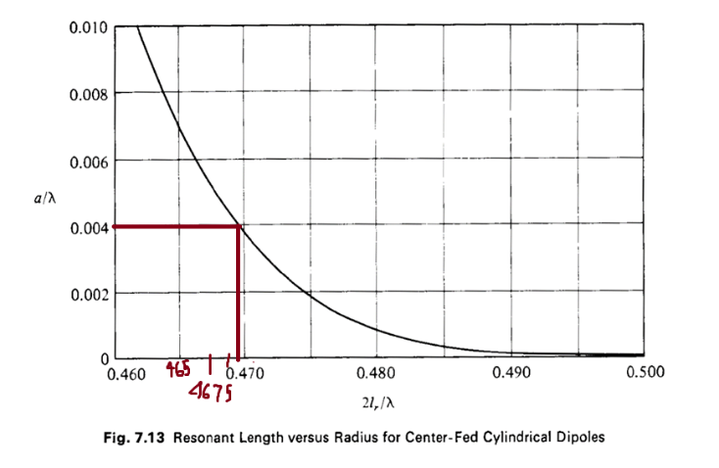

Optimal Length for first resonance.

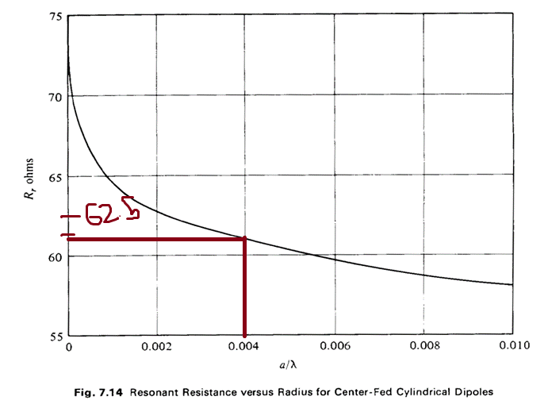

Input Impedance for first resonance.

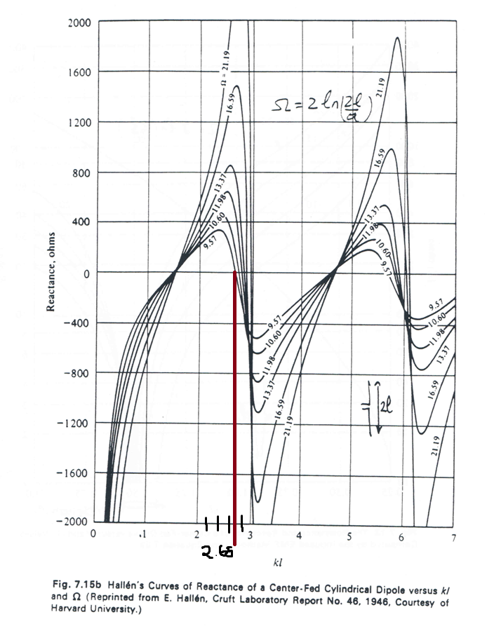

Optimal Length for Second Resonance.

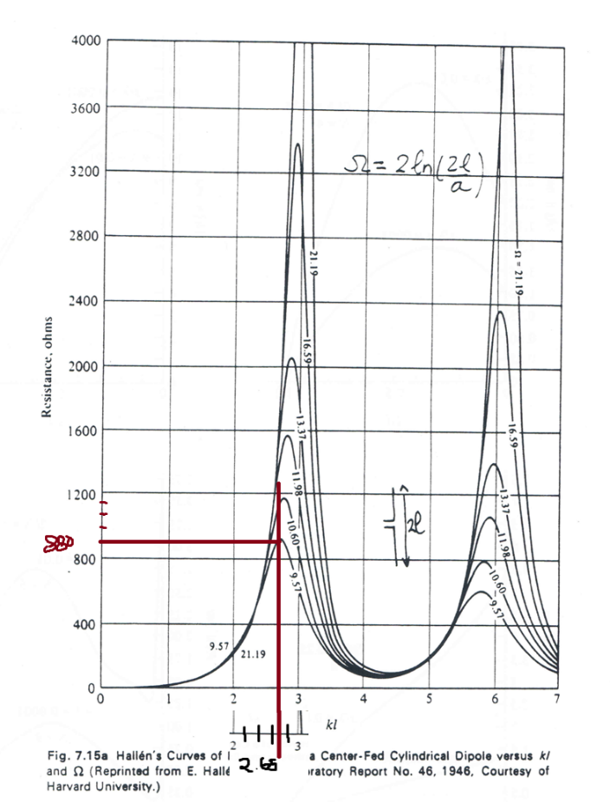

Input Impedance for Second Resonance.

* 1. The mutual impedance and new input impedance of the slot antenna at first resonance when placed λ/4 away from a ground plane. Do it using (1) image theory and slot antenna and (2) the complete dual and replacing all metals with air and all airs with metal. Prove that they are the same.

1. Consider the patch antenna with thickness t<<λ, dielectric constant εr, and dimension (a, b). for (m, n)=(0,1), and εr=2.2 and 10.2 (two cases),
   1. Calculate the dimensions of the antenna to resonate at 1.57 GHz. Choose b=1.4a.
   2. Draw the magnetic current and electric field distribution on the faces x=0, x=a, y=0, y=b. For one case only.
   3. Calculate and plot the E, H, and phi=52 degree patterns by considering the magnetic currents on the faces y=0, y=b (linear polar). Calculate the directivity. Why the directivity of the antenna with εr=2.2 is higher? Which antenna is better for GPS application?
   4. Calculate and plot the E, H, and phi=52 degree patterns by considering the magnetic currents on the faces x=0, x=a (linear polar). Compare with the co-pol. Pattern in (3). Make sure they are scaled to the same constant so that you can compare their relative magnitude. What is the cross-pol. Level in dB for the two cases?
2. For a horn antenna with TE20 mode on the x-axis with a=8λ (x-axis) and b=5λ (y-axis):
   1. Calculate the far field pattern. Plot the E and H plane patterns together on a rectangular, -30dB-0dB range, for 0<θ<90o.
   2. Find the peak radiation angle. Calculate the directivity and aperture efficiency at the peak radiation angle.
3. Take a rectangular aperture with |x|<a/2 and |y|<b/2, (a=6λ and b=8λ). surrounded by an infinite ground-plane. The electric field across the aperture is given by

for

* 1. Calculate the E and H plane patterns. Plot the E-plane in phase, quadrature and total patterns for $α{(a/2)}^{2}=π/4$, on a rectangular, -30dB-0dB range, for 0<θ<90o. (hint: calculate f(kx, ky) first)
  2. Calculate the aperture efficiency. Use the coupling formula.



1. Design a 23-dBi standard gain horn antenna for 18-26 GHz operations (K band). The feeding waveguide is WR42 (find the waveguide dimensions on internet). The gain is specified at 22 GHz. Plot the gain and aperture efficiency at 14-32 GHz. What is the phase error across the x and y direction at 18 and 26 GHz, respectively? To what maximum frequency you would like to use this horn, What is the limiting factor?

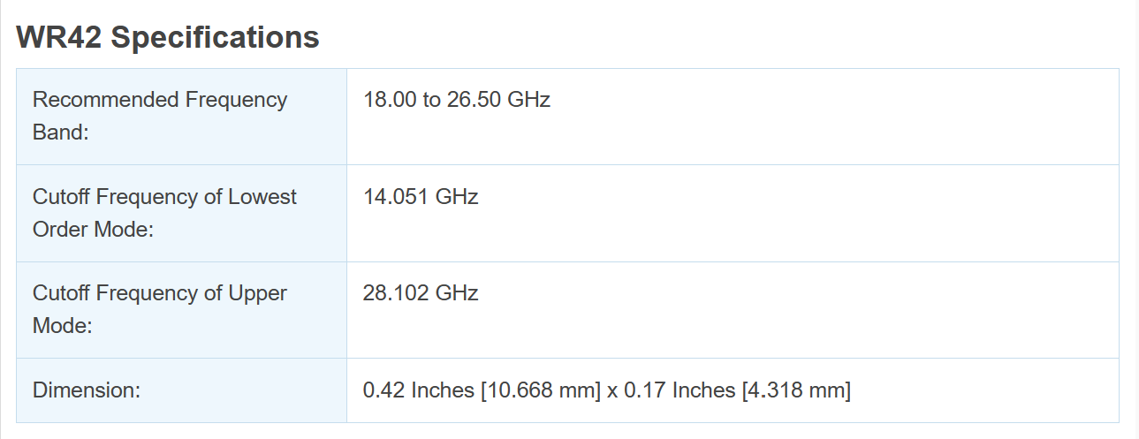

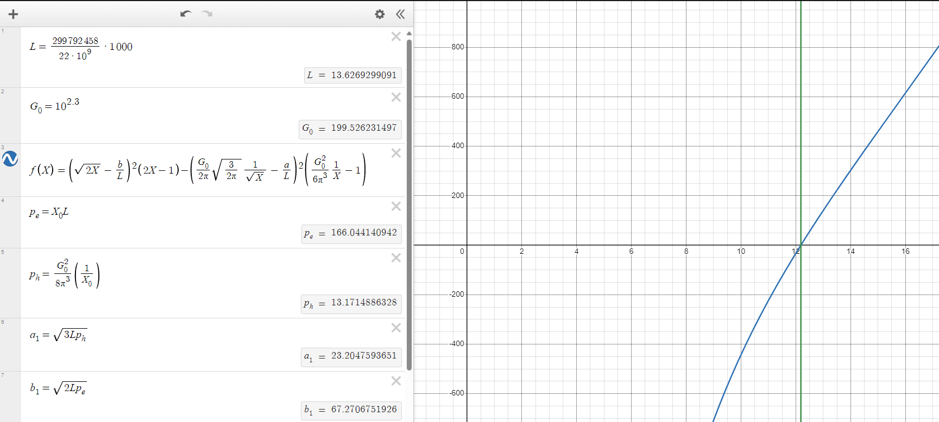

(Design Graph)

[HornAntenna | Desmos](https://www.desmos.com/calculator/ofit7vz7bn)

